Map Scale
# Source: AI Source: Provided by: [Data Path: Persons Table -> ID Column: 1, Name_En Column: Motasem Essam] -> From: [ChatGPT] on [7/17/2026]
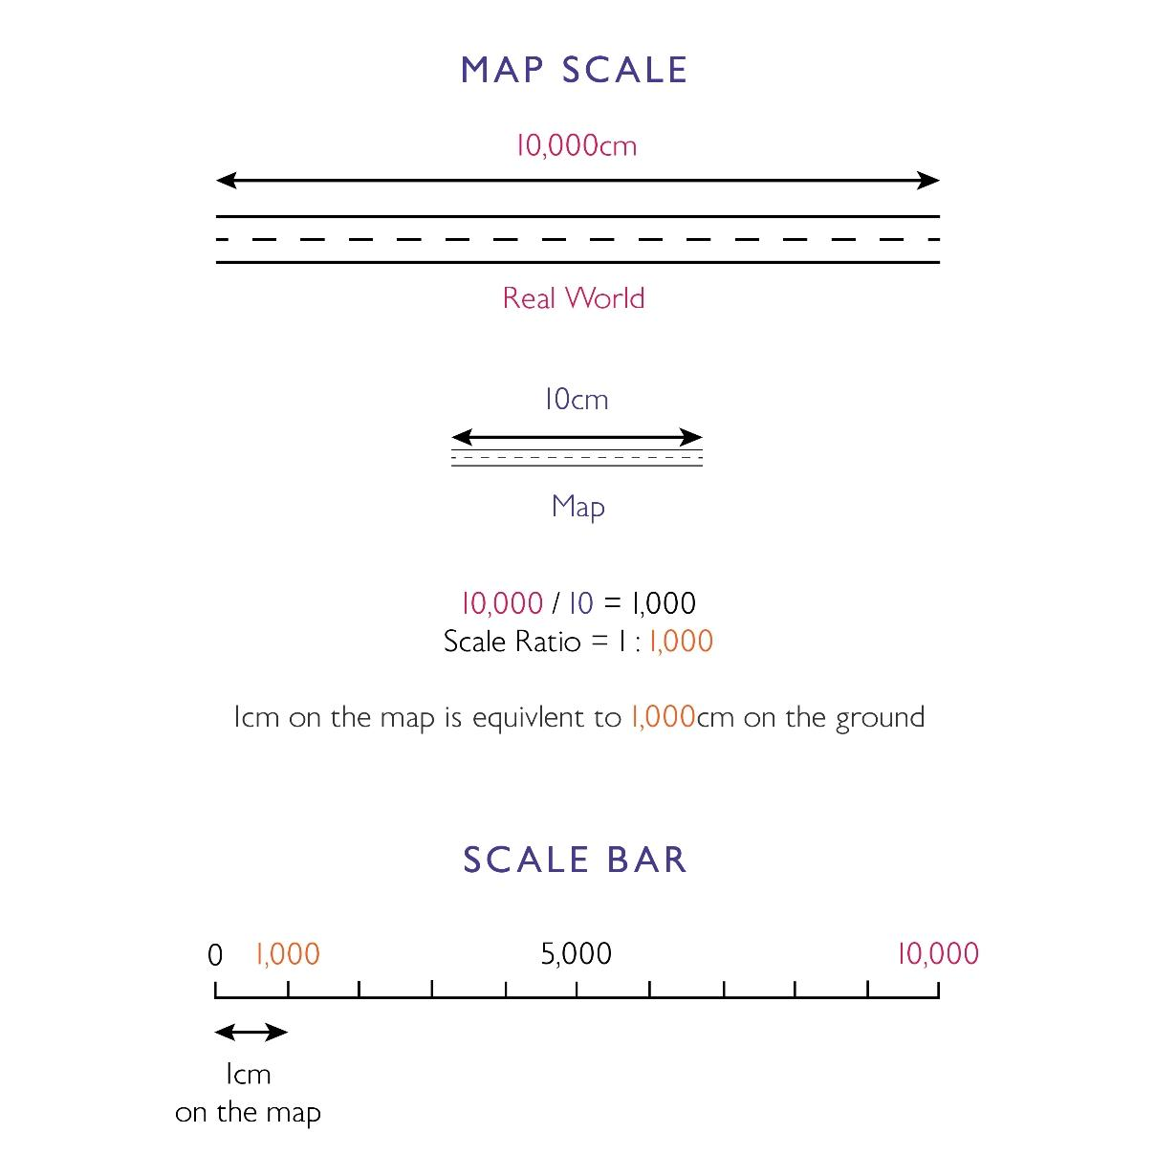

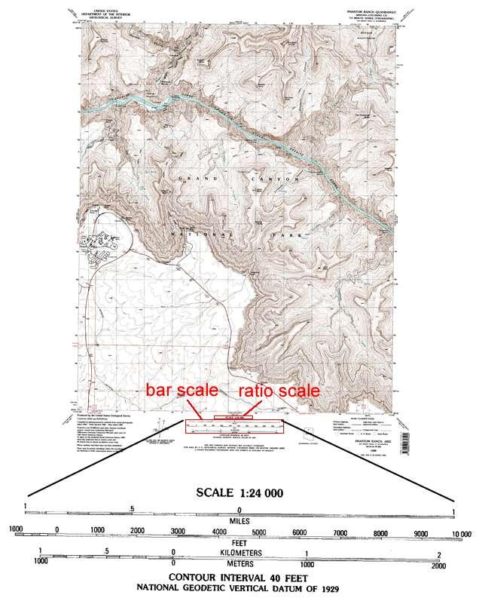
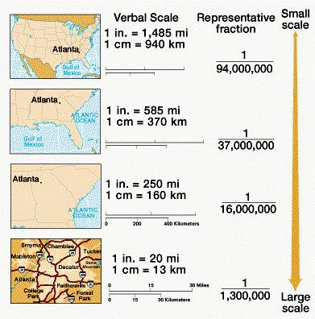
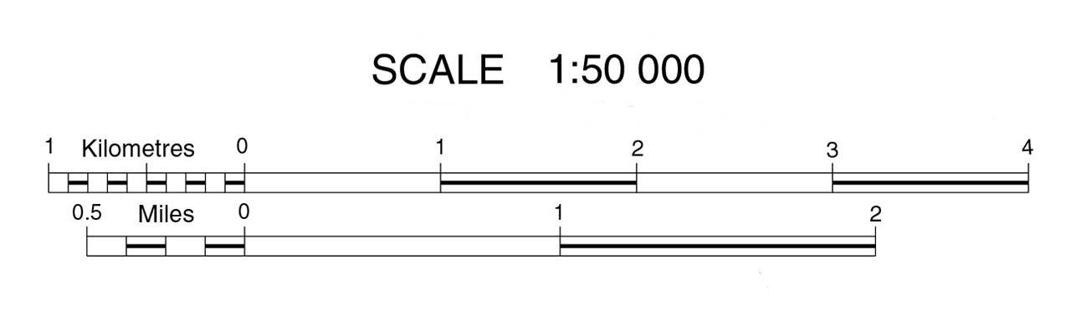
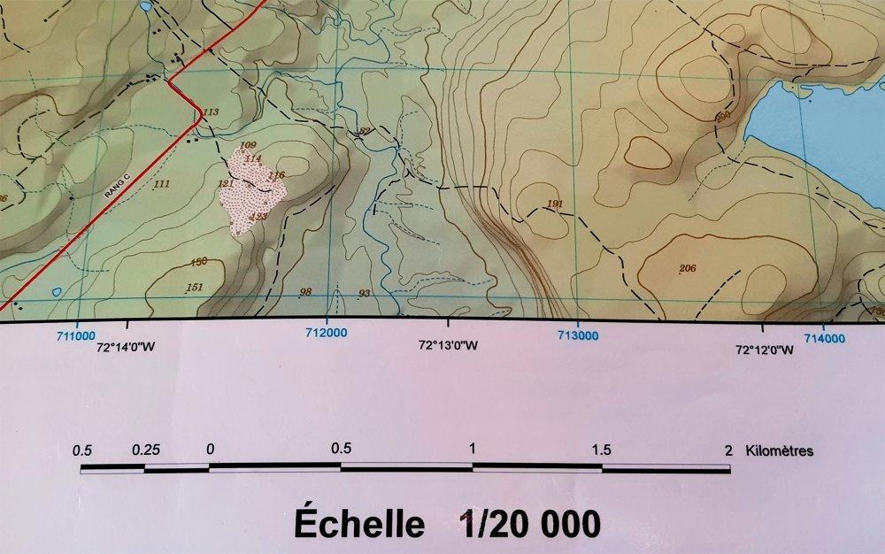
A Map Scale is the relationship between a distance measured on a map and the corresponding actual distance on the Earth's surface. It enables users to calculate real-world distances, estimate travel lengths, and interpret the relative size of geographic features.
Map scales are fundamental in cartography, geography, surveying, engineering, navigation, urban planning, and GIS (Geographic Information Systems).

Definition
# Source: AI Source: Provided by: [Data Path: Persons Table -> ID Column: 1, Name_En Column: Motasem Essam] -> From: [ChatGPT] on [7/17/2026]
A Map Scale is the ratio that compares a distance on a map with the corresponding distance on the ground.

Purpose
# Source: AI Source: Provided by: [Data Path: Persons Table -> ID Column: 1, Name_En Column: Motasem Essam] -> From: [ChatGPT] on [7/17/2026]
Map scales are used to:
- Measure real-world distances.
- Estimate travel routes.
- Interpret geographic data.
- Create accurate maps.
- Support surveying and engineering.
- Perform GIS analysis.

Principle
# Source: AI Source: Provided by: [Data Path: Persons Table -> ID Column: 1, Name_En Column: Motasem Essam] -> From: [ChatGPT] on [7/17/2026]
Every map uses a constant ratio between map distance and ground distance.
$$\text{Scale}=\frac{\text{Map Distance}}{\text{Ground Distance}}$$
For example,
$$1:50,000$$
means:
- 1 unit on the map = 50,000 of the same units on the ground

Types of Map Scales

1. Representative Fraction (RF) Scale
# Source: AI Source: Provided by: [Data Path: Persons Table -> ID Column: 1, Name_En Column: Motasem Essam] -> From: [ChatGPT] on [7/17/2026]
The scale is written as a ratio.
Examples:
- 1:1,000
- 1:10,000
- 1:50,000
- 1:250,000
Example:
$$1:100,000$$
means:
- 1 cm on the map represents 100,000 cm (1 km) on the ground.

2. Verbal (Statement) Scale
# Source: AI Source: Provided by: [Data Path: Persons Table -> ID Column: 1, Name_En Column: Motasem Essam] -> From: [ChatGPT] on [7/17/2026]
The scale is written in words.
Examples:
- 1 cm represents 1 km
- 1 inch represents 1 mile
This format is easy for general users to understand.

3. Graphic (Bar) Scale
# Source: AI Source: Provided by: [Data Path: Persons Table -> ID Column: 1, Name_En Column: Motasem Essam] -> From: [ChatGPT] on [7/17/2026]
A graphic or bar scale is drawn directly on the map.
0 1 2 3 km
|-----|-----|-----|
Advantages:
- Remains useful even if the map is enlarged or reduced.
- Easy to measure distances with a ruler.

Classification by Scale Size

Large-Scale Maps
# Source: AI Source: Provided by: [Data Path: Persons Table -> ID Column: 1, Name_En Column: Motasem Essam] -> From: [ChatGPT] on [7/17/2026]
Show a small geographic area with high detail.
Typical scales:
- 1:500
- 1:1,000
- 1:5,000
- 1:10,000
Examples:
- Building plans
- Campus maps
- City maps

Medium-Scale Maps
# Source: AI Source: Provided by: [Data Path: Persons Table -> ID Column: 1, Name_En Column: Motasem Essam] -> From: [ChatGPT] on [7/17/2026]
Show moderate detail.
Typical scales:
- 1:25,000
- 1:50,000
Examples:
- Topographic maps
- Hiking maps

Small-Scale Maps
# Source: AI Source: Provided by: [Data Path: Persons Table -> ID Column: 1, Name_En Column: Motasem Essam] -> From: [ChatGPT] on [7/17/2026]
Show very large geographic areas with less detail.
Typical scales:
- 1:250,000
- 1:500,000
- 1:1,000,000
Examples:
- National maps
- Continental maps
- World maps

Formula
# Source: AI Source: Provided by: [Data Path: Persons Table -> ID Column: 1, Name_En Column: Motasem Essam] -> From: [ChatGPT] on [7/17/2026]
Ground Distance
$$\text{Ground Distance}=\text{Map Distance}×\text{Scale Factor}$$

Map Distance
$$\text{Map Distance}=\frac{\text{Ground Distance}}{\text{Scale Factor}}$$

Example
# Source: AI Source: Provided by: [Data Path: Persons Table -> ID Column: 1, Name_En Column: Motasem Essam] -> From: [ChatGPT] on [7/17/2026]
Scale:
$$1:50,000$$
Map distance:
$$8\text{ cm}$$
Ground distance:
$$8×50,000=400,000\text{ cm}$$
Convert to kilometers:
$$400,000\text{ cm}=4,000\text{ m}=4\text{ km}$$
Therefore,
8 cm on the map represents 4 km on the ground.

Common Map Scales
# Source: AI Source: Provided by: [Data Path: Persons Table -> ID Column: 1, Name_En Column: Motasem Essam] -> From: [ChatGPT] on [7/17/2026]
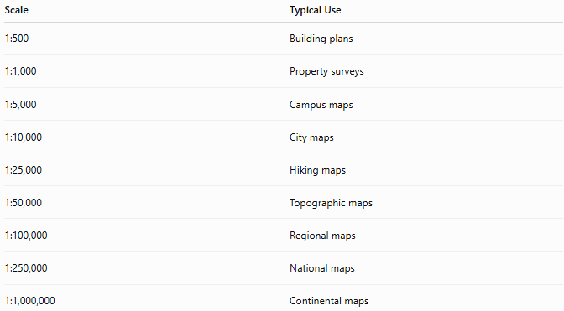
Scale | Typical Use
1:500 | Building plans
1:1,000 | Property surveys
1:5,000 | Campus maps
1:10,000 | City maps
1:25,000 | Hiking maps
1:50,000 | Topographic maps
1:100,000 | Regional maps
1:250,000 | National maps
1:1,000,000 | Continental maps

Applications
# Source: AI Source: Provided by: [Data Path: Persons Table -> ID Column: 1, Name_En Column: Motasem Essam] -> From: [ChatGPT] on [7/17/2026]
Map scales are used in:
- Cartography
- Surveying
- Navigation
- GIS
- Civil engineering
- Urban planning
- Geography
- Military operations
- Environmental studies

Advantages
# Source: AI Source: Provided by: [Data Path: Persons Table -> ID Column: 1, Name_En Column: Motasem Essam] -> From: [ChatGPT] on [7/17/2026]
Map scales:
- Allow accurate distance measurement.
- Preserve geographic proportions.
- Simplify map interpretation.
- Support route planning.
- Improve geographic analysis.

Limitations
# Source: AI Source: Provided by: [Data Path: Persons Table -> ID Column: 1, Name_En Column: Motasem Essam] -> From: [ChatGPT] on [7/17/2026]
Map scales:
- Cannot represent every feature at very small scales.
- Lose detail when representing large areas.
- May become inaccurate if maps are improperly resized (except graphic scales).

Sources of Error
# Source: AI Source: Provided by: [Data Path: Persons Table -> ID Column: 1, Name_En Column: Motasem Essam] -> From: [ChatGPT] on [7/17/2026]
Instrument Errors
- Incorrect ruler calibration
- Printing distortion

User Errors
- Misreading the scale
- Using incorrect units
- Measuring curved routes as straight lines

Environmental Errors
- Paper expansion due to humidity
- Printer scaling changes

Comparison of Scale Types
# Source: AI Source: Provided by: [Data Path: Persons Table -> ID Column: 1, Name_En Column: Motasem Essam] -> From: [ChatGPT] on [7/17/2026]
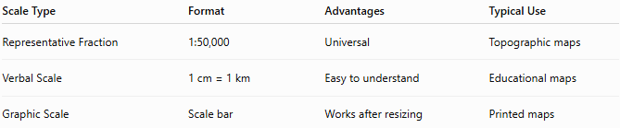
Scale Type | Format | Advantages | Typical Use
Representative Fraction | 1:50,000 | Universal | Topographic maps
Verbal Scale | 1 cm = 1 km | Easy to understand | Educational maps
Graphic Scale | Scale bar | Works after resizing | Printed maps

Best Practices
# Source: AI Source: Provided by: [Data Path: Persons Table -> ID Column: 1, Name_En Column: Motasem Essam] -> From: [ChatGPT] on [7/17/2026]
- Always verify the map scale before measuring.
- Use the same units when performing calculations.
- Prefer the graphic scale if the map may be photocopied or digitally resized.
- Use appropriate tools for measuring curved routes.

Key Points
# Source: AI Source: Provided by: [Data Path: Persons Table -> ID Column: 1, Name_En Column: Motasem Essam] -> From: [ChatGPT] on [7/17/2026]
- A Map Scale relates map distance to actual ground distance.
- Three main formats:
  - Representative Fraction (RF)
  - Verbal Scale
  - Graphic (Bar) Scale
- Maps are classified as:
  - Large-scale
  - Medium-scale
  - Small-scale
- Map scales are essential for accurate geographic measurement and interpretation.

Conclusion
# Source: AI Source: Provided by: [Data Path: Persons Table -> ID Column: 1, Name_En Column: Motasem Essam] -> From: [ChatGPT] on [7/17/2026]
A Map Scale defines the relationship between distances on a map and their corresponding distances on the Earth's surface. By using representative fractions, verbal statements, or graphic scale bars, map scales enable accurate measurement, navigation, surveying, and spatial analysis. They are fundamental tools in cartography, geography, engineering, urban planning, GIS, and navigation, ensuring that maps remain reliable representations of the real world.

